**Linux Assignment -5**

1. Write a program for case statements?

**Program: -**

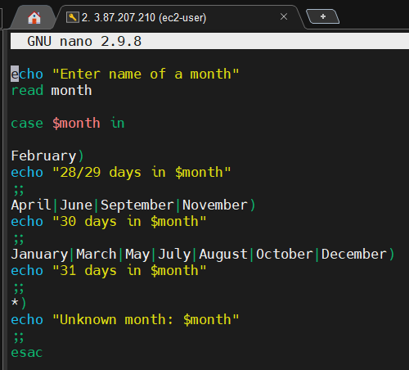

**Output: -**

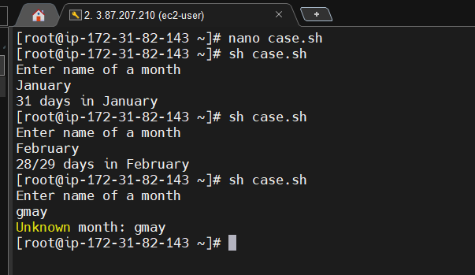

1. Examples of array programs in bash?

**Program: -**

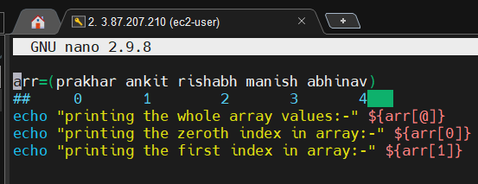

**Output: -**

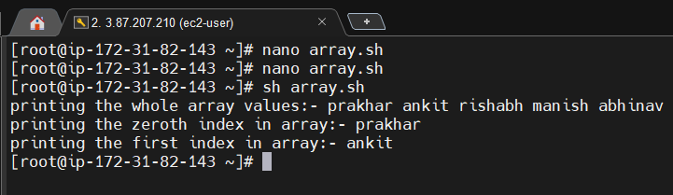

**Example: -2**

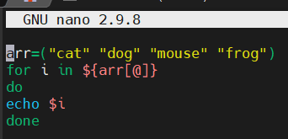

**Output: -**

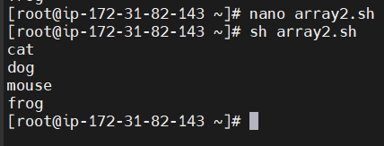

1. Write two programs using functions in bash?

**Program: -**

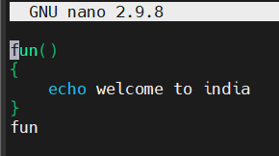

**Output: -**

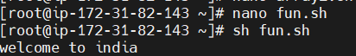

**Example 2: -**

**Program: -**

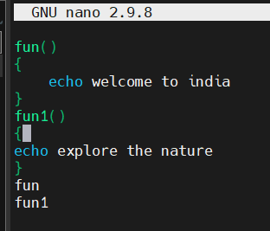

**Output: -**

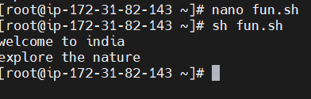

1. 2 examples on passing the arguments?

**Program: -**

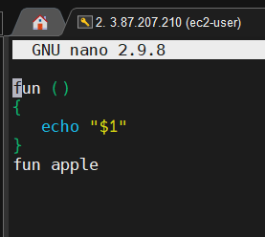

**Output: -**

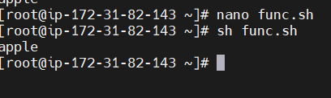

**Example 2: -**

**Program: -**

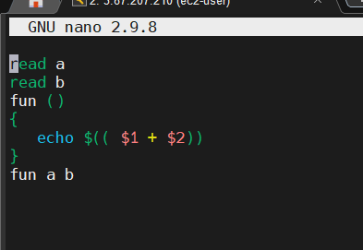

**Output: -**

